User Manual

1. Installation Instructions
2. Overview
3. Game set up
4. Dice Roll
5. Building
6. Development Cards
7. Trading Resources
8. Maritime Trade
9. Installation Instructions

I don’t have the latest Java Runtime (JRE):

The instructions for installing the latest JRE can be found here: <http://docs.oracle.com/javase/8/docs/technotes/guides/install/install_overview.html>

I have the latest Java Runtime (JRE):

Open the Catan.jar file and begin playing. The Icon can be moved to any folder in your operating system.

Troubleshooting:

* **Windows and Mac**
  + The instructions for checking your Java JRE version can be found here: <https://www.java.com/en/download/help/version_manual.xml>
* **MacOS**
  + If the message “Catan.jar can’t be opened because it is from an unidentified developer.” is displayed:
    - Hold the control button down while you click the icon.
    - Select Open from the window
    - A waring message will display asking if you are sure you want to open an application from an unidentified developer. Choose Open.
    - The application should open normally in the future.
* **Ubuntu**
  + If an error messages displays indicating the file is from an untrusted source:
    - Right click on the icon
    - Select Properties
    - Select Permissions
    - Click the box next to the “Allow executing file as a program” option.
    - Close the window.
    - The game should open normally now

1. Overview

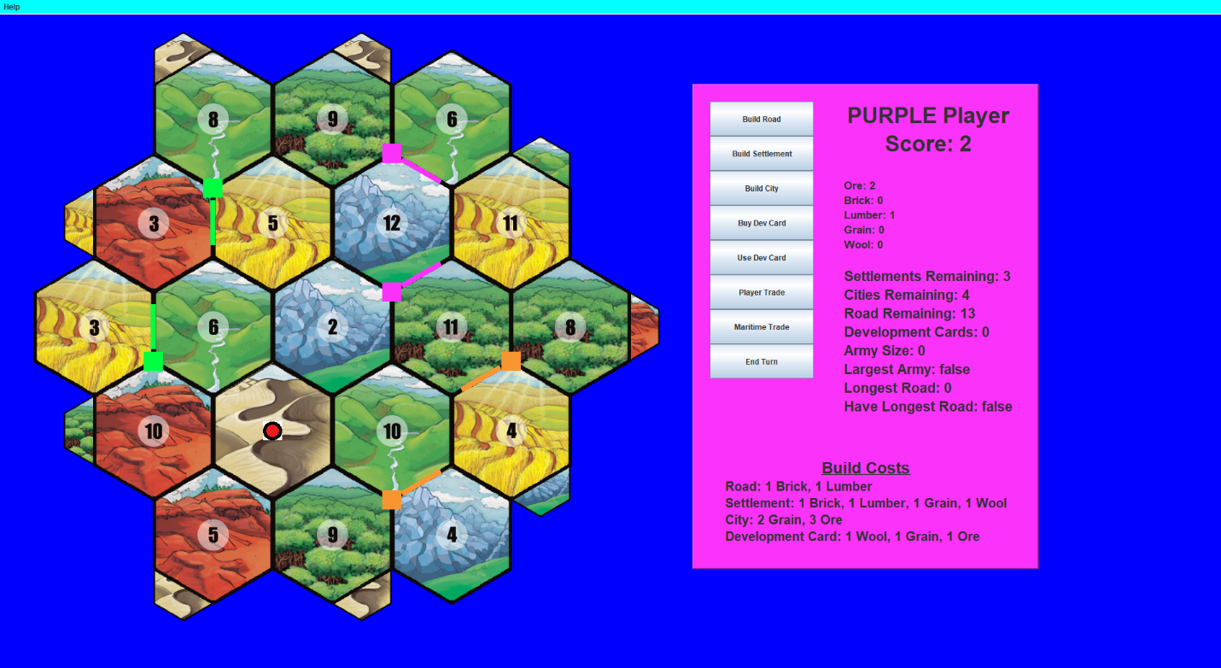

The game board consists of 19 hexagonal resource tiles. Each tile is associated with one resource, except the desert tile, which does not produce a resource.

Mountain Hill Forest Field Valley Desert

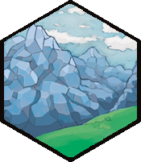 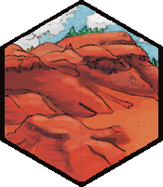 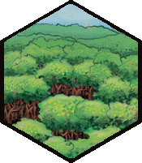 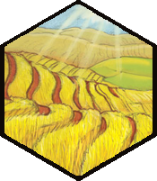 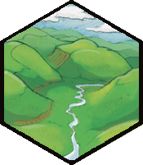 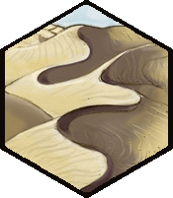

Mountains produce Ore, Hills produce Brick, Forests produce Lumber, Fields produce Grain and Valleys produce Wool. Each resource tile, which is not the desert, has a number in the middle. The desert begins with the Robber, . (More on the Robber later).

Typical set up. GUI

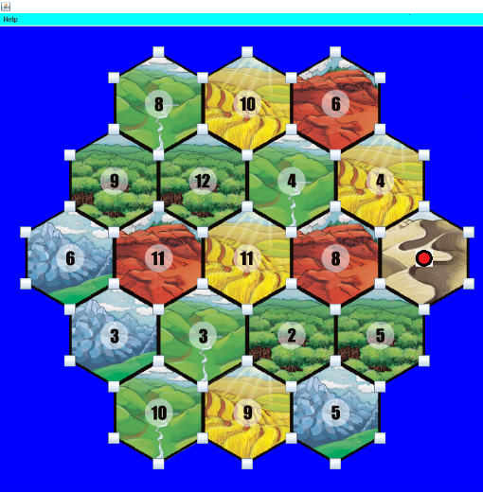 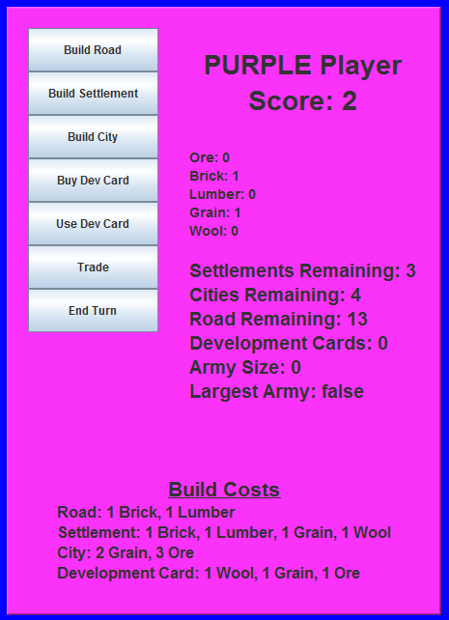

 Settlement  City.  Road.

To begin each turn, the current player ‘rolls’ the dice. If the value of the dice roll is equal to the number in tile, that tile produces resources for that round. Players receive one resource for each settlement and two resources for each city on the corners of that tile. Players will use these resources to build roads, settlements and cities. Development cards may also be purchased with these resources. Each player owns 5 settlements, 4 cities and 15 roads. The winner is the first to score 10 victory points. Victory points can be earned in a variety of ways, which will be covered through the user manual in the appropriate sections. The current player’s score, resources, game pieces, development cards and build costs may be referenced on the GUI.

1. Game Set-up

To start the game, click on the Catan.jar icon. A window will pop up asking you the number of players. After choosing the number of players, a board will appear and inform the user that it is time for the first player to set their initial settlement with an adjacent road. Buttons will appear on the game board where settlements may be placed, which are at the corners of the tiles.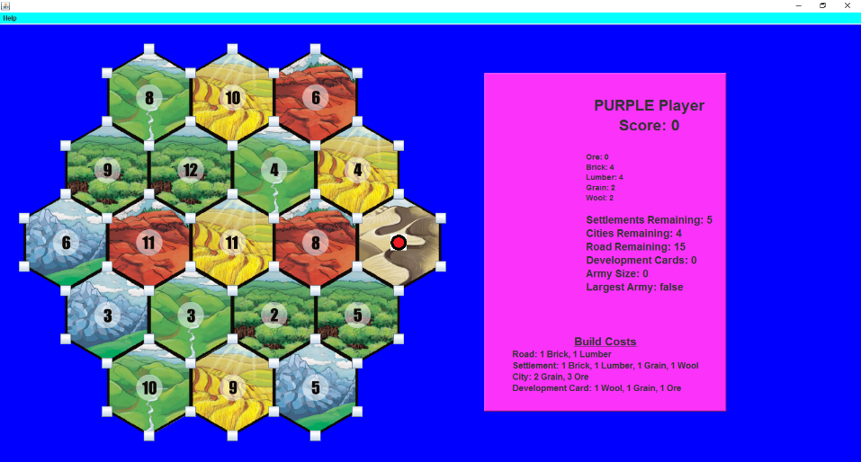

After you place your settlement, you must place a road, which is adjacent to the settlement you just placed. Roads are placed along the edges of the tiles. Buttons will appear where you may place a road.

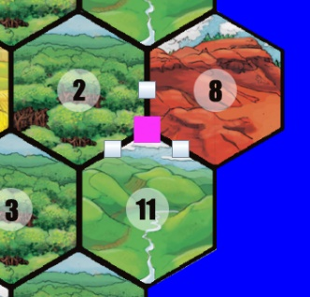 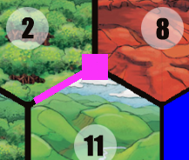 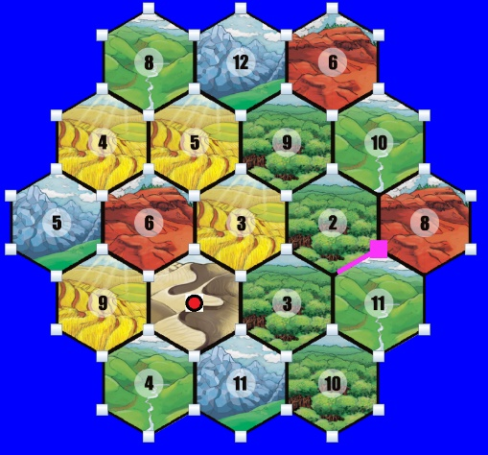

Before Road Placed After Road Placed Settlements cannot be adjacent.

After the player places a road, the next player will place a settlement and a road. Settlements may NOT be placed in adjacent resource tile corners. In the image below, you can see that buttons are not available for settlement locations which are one road length away from other settlements. This process continues until each player has one settlement and road on the board. Then the process is repeated except that the player order is reversed for the second round. Once each player has two settlements and adjacent roads, the first player will roll the dice (click the OK button on pop up screen when ready to roll) and normal play will begin.

1. Dice Roll

Each turn begins by rolling the dice, which is clicking the OK button on the pop up window after the last player finishes their turn. When any number other than a seven is rolled, each resource tile with a number that matches the roll produces resources to players with settlements or cities on the corners of the tile. Players get one resource for each settlement and two resources for each city. The resource tile which contains the robber cannot produce any resources.

The orange player would get two grain resources and the purple player would get one if a 5 were rolled for the image on the left below.

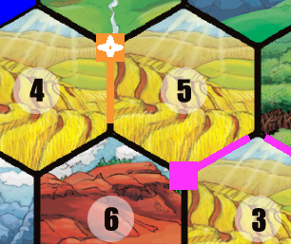 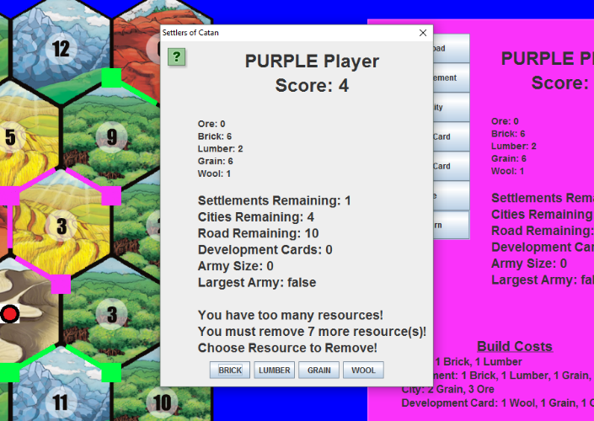

If a 7 is rolled, each player with more than seven resources MUST remove half of their resources, rounded down. For instance, in the image above on the right, the purple player has 15 total resources, so they must get rid of 7. You choose one at a time by clicking on the buttons at the bottom of the window.

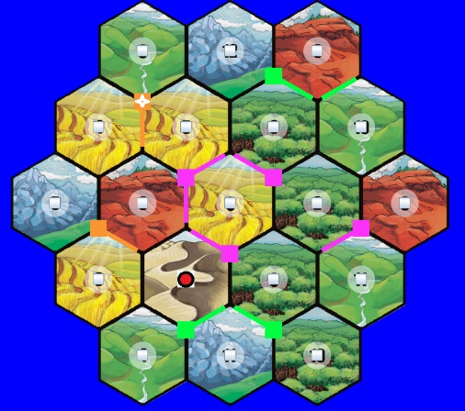 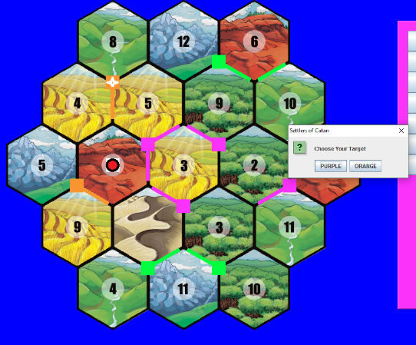

Next, the player who rolled the 7 must move the robber from the tile is currently on to a new tile. Buttons will appear at the center of the tiles when the robber is to be moved, image above to the left. After the robber is moved, image above to the right, the current player may steal a random resource from any player with a settlement or city on a corner of the tile by selecting the color of the player in the pop up window.

1. Building Roads, Settlements, and Cities

Roads cost 1 brick and 1 lumber to build. They may be built along tile edges which are adjacent to edges which already have one of the current player’s roads. Buttons will pop up when you click the ‘Build Road’ button on the GUI. In the image below, you can see where the Green player may build roads.

* **Longest Road**: The number of consecutive roads, not counting forks.
* **Have Longest Road**: The first player to build a road with a length of 5 will have the longest road, which counts for 2 victory points. For another player to take the ‘Longest Road’ title, they must surpass the size of the current ‘Longest Road.’

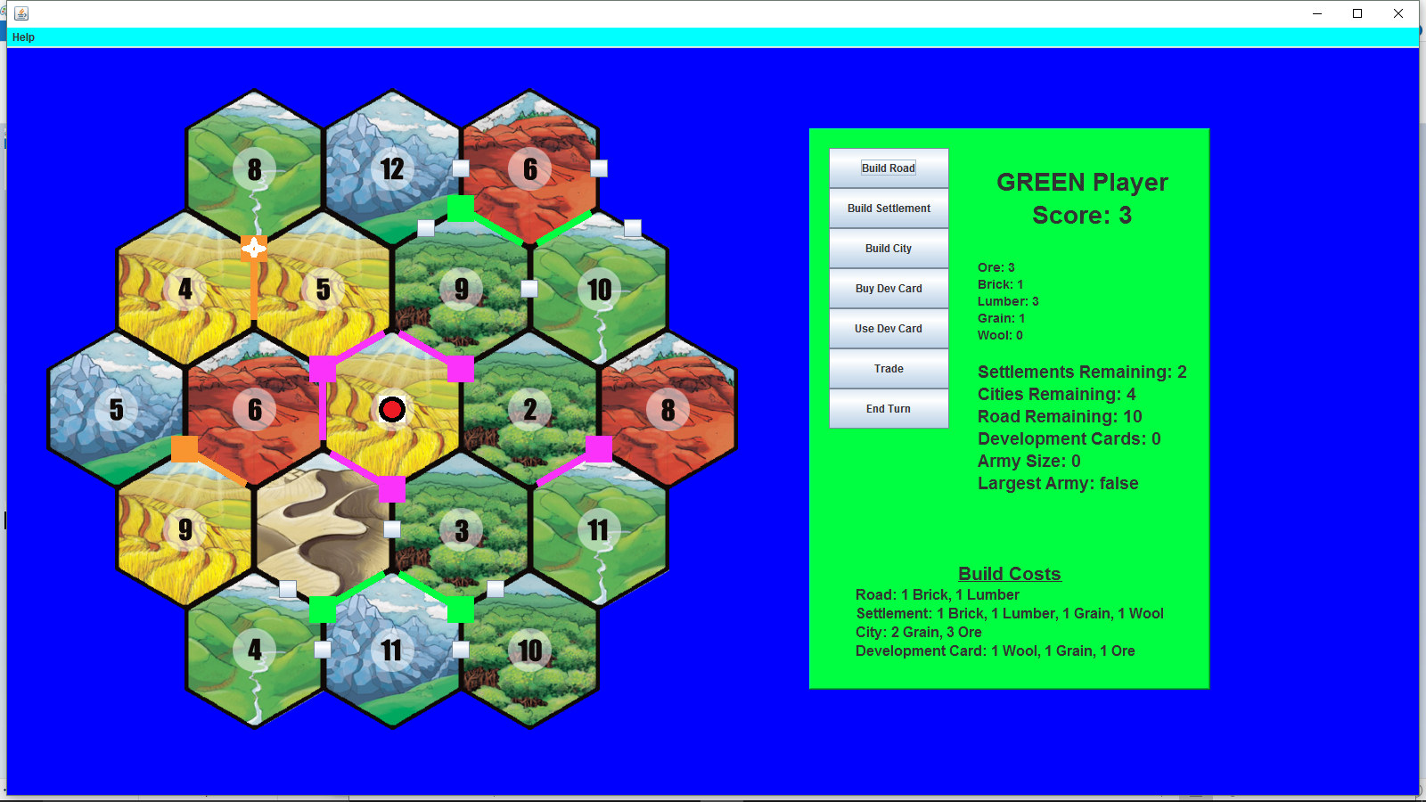

Settlements cost 1 brick, 1 lumber, 1 grain and 1 wool to build. They may be built at tile corners which have one of the player’s roads in an adjacent tile edge. Also, they must be at least two corners away from any other settlements. When you request to build a settlement, buttons will appear in places where builds may take place. In the image below, the Green player may only build a settlement in one location. Settlements are worth 1 victory point.

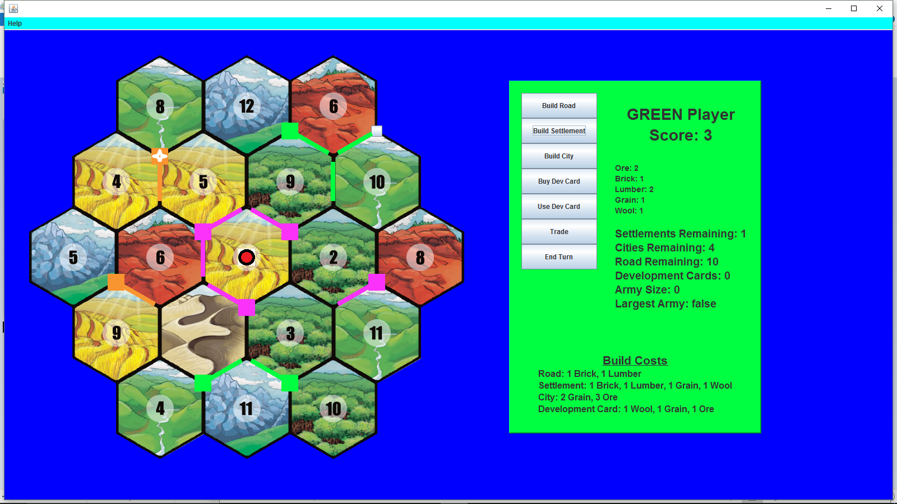

Cities cost 3 ore and 2 grain resources to build. Cities may only be placed where a settlement currently exists. The button to place a city will not appear until you hover the mouse over the settlement. Notice the orange player’s settlement below.

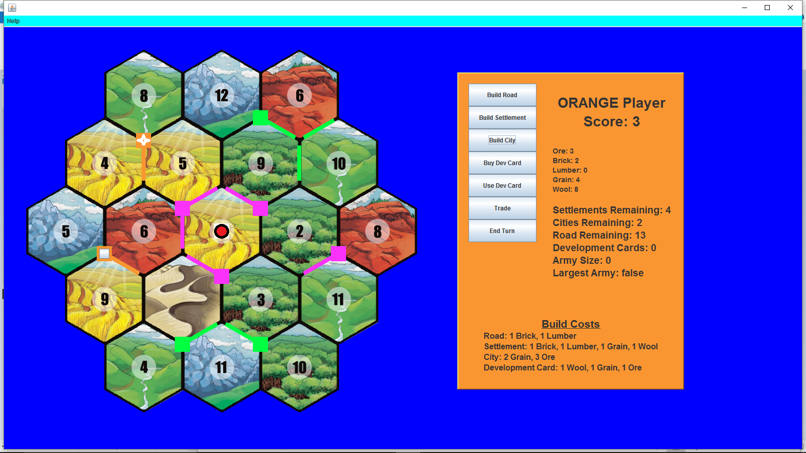

When you build a city, the settlement that you build on will be placed back into your inventory so it is available to place again. Cities are worth 2 victory points.

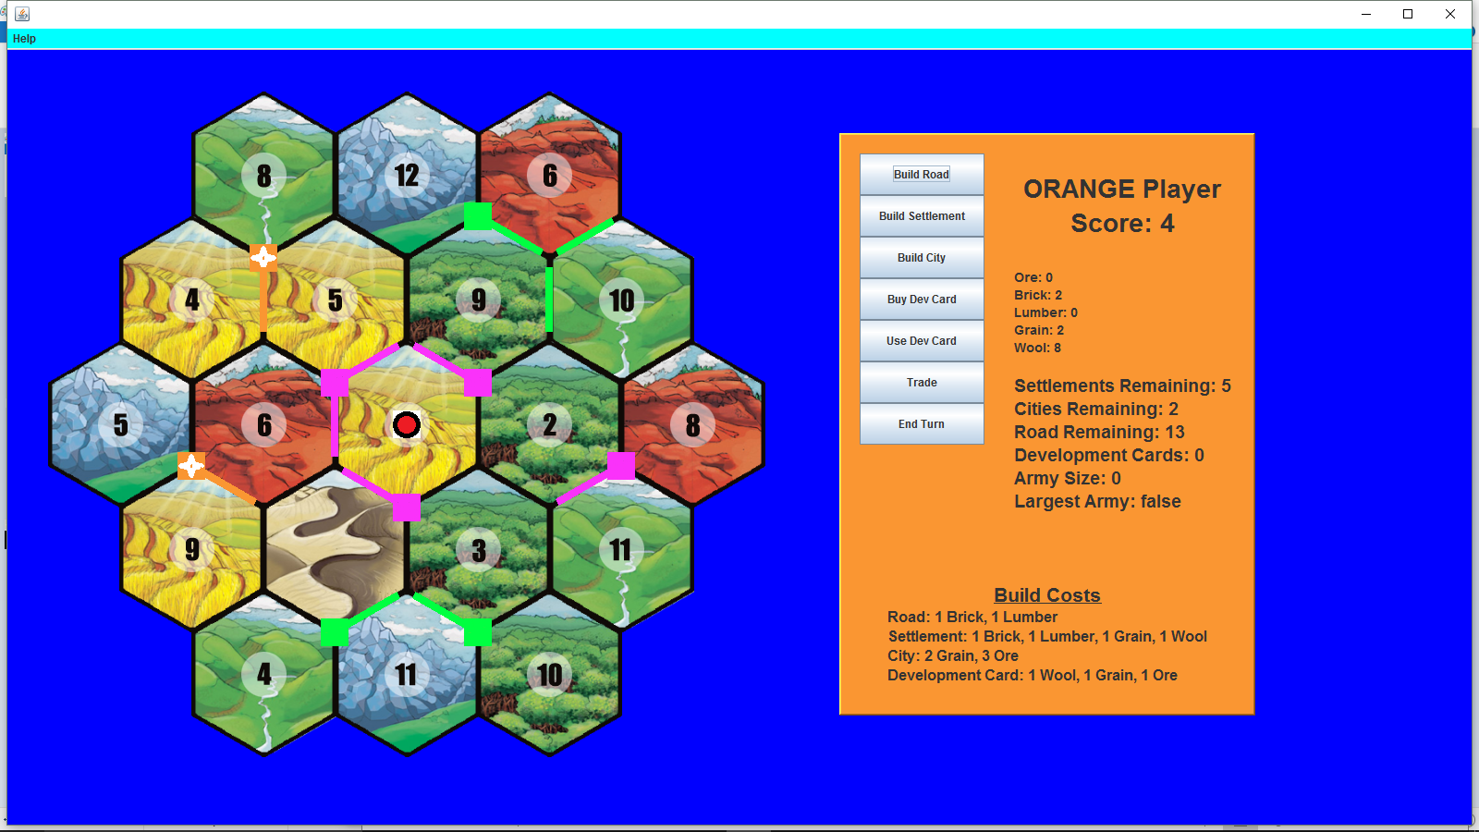

1. Development Cards

Development cards can be purchased for 1 ore, 1 grain and 1 wool. To buy a development card, click the ‘Buy Dev Card’ button. There are five distinct types of development cards.

1. ***Victory Point***: When played, these add one to your score. There are 5 in the deck.
2. ***Year of Plenty***: When played, you may choose two resources of any type. There are 2 in the deck.
3. ***Road Building***: When played, the player must place 2 roads on the board. Locations where roads may be placed will have buttons. There are 2 in the deck.
4. ***Monopoly Card***: When played, the current player will choose a resource type. Every other player must give the current player all their resources of that type. There are 2 in the deck.
5. ***Knight Card:*** When played, the current player may move the robber and steal a resource from a player with a settlement or a city on the corner of the tile where the robber is moved. Players with more than 7 cards do not have to remove resources. There are 14 in the deck.

* **Army Size**: The number of knight’s a player has played.
* **Largest Army**: The first player to play 3 knights receives the ‘Largest Army’ title, which counts for 2 victory points. For another player to take the ‘Largest Army’ title, they must surpass the size of the current ‘Largest Army.’

To use a development card, click the ‘Use Dev Card’ button. A window will pop up showing your development cards. To use one, click on the appropriate button. You can close the window without using a card.

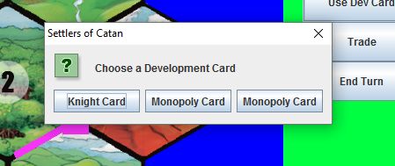

1. Trading Resources

Trading resources is very useful. When you trade, you can build more and can avoid having to remove resources when a 7 is rolled. To trade, click the ‘Trade’ button. A window listing your resources will pop up. Click the resource you want to offer in the trade.

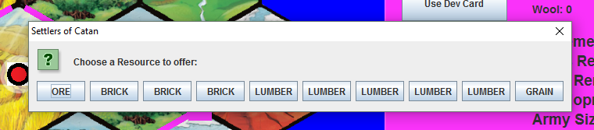

You may offer more than one resource in the trade.

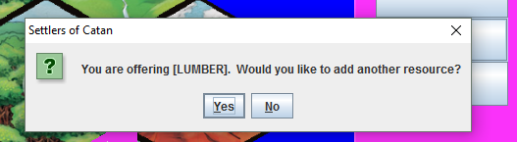

Choose which resource you are requesting in the trade.

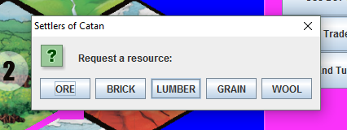

You may request more than one resource.

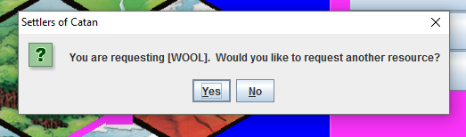

When you are finished requesting resources, each player who has the requested resources will be offered the trade (starting with the first and going in player order). Each player with the requested resources can choose to accept or reject the offer.

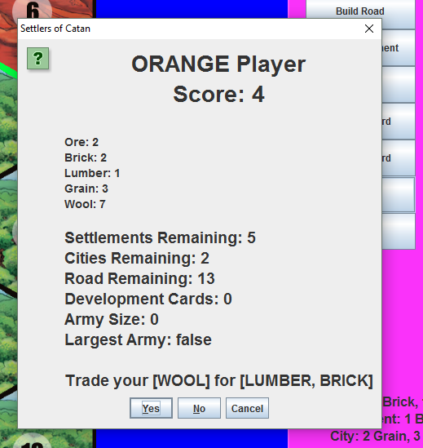

1. Maritime Trade

Harbors are indicated by trapezoids which protrude into the ocean from the resource tiles. You can see three harbors in the image below, a brick harbor on the bottom left protruding from a hill resource tile, an ore harbor protruding from a forest tile and a grain harbor protruding from the mountain tile.

When a settlement or a city is built on a harbor, the player who owns the settlement or city may trade two of the harbor resources for any resource they choose.

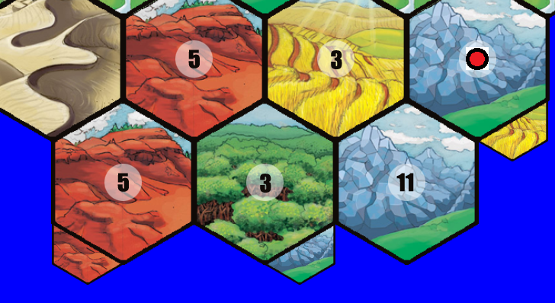

Harbors with a desert image may trade three resources for any resource they choose. These three resources can be any resource, but they all must be the same resource. A desert harbor is pictured protruding from the valley resource tile below.

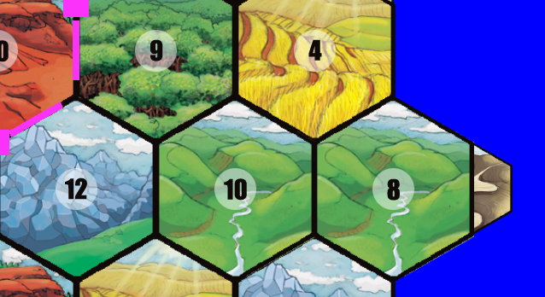

At any point, a player may trade four of any resource for any resource they choose. These four resources can be any resource, but they all must be the same resource. No harbor is needed for this maritime trade.